How to Write a Scientific Explanation Name:_______
Components
- Make a claim about the problem.
- Provide evidence for the claim.
- Provide reasoning that links the evidence to the claim.

Definitions
- Claim: An assertion or conclusion that answers the original question
- Evidence: Scientific data that supports the student’s claim that must be appropriate and sufficient. Can come from an investigation or other source such as observations, reading material, archived data, or other source.
- Reasoning: Justification that links the claim and evidence. Shows why the data counts as evidence to support the claim, using appropriate scientific principles.

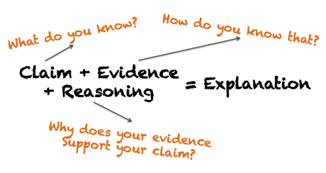
Qualities of Communication
Write the explanation so others can understand it.
- Use precise and accurate scientific language.
- Write clearly so that anyone interested in the explanation can understand it.
- Explain your logic to help share your knowledge.

Explanation Tool Layout
The Question:
Initial question based on an observed phenomenon or situation.
Our Claim:
Your claim is a statement that expresses the answer or conclusion to the question.
Our Evidence:  Your evidence should always include collected data (Numbers!) and/or observations | Our Justification (Reasoning) of the Evidence:  Your justification explains why the evidence supports the claim. Provide a logical connection between the evidence and claim.

Examples of Claim, Evidence, and Reasoning (in order of increasing complexity)
Example 1
The Question:
What do plants need to grow?
Our Claim:
The plant that received more light grew taller.
Our Evidence:  The plant with 24 hours of light grew 20 cm. The plant with 12 hours of light only grew 8 cm. | Our Justification of the Evidence:  Plants require light to grow and develop. This is why the plant that received 24 hours of light grew taller.

Teacher Comments: This example provides a simple claim that focuses on one variable that plants need to grow— light. The example provides evidence to support the claim from an experiment that focused solely on comparing plants that received 24 hours of light with those that received 12 hours. The actual data is not complex; rather, it is limited to support the sense-making process and in writing the scientific explanations. The reasoning is also fairly simple, but it is a good start at thinking about why data counts as evidence to support the claim.

Example 2
The Question:
What do plants need to grow?
Our Claim:
The plant that received more light grew more.
Our Evidence:  On average, for the six plants that received 24 hours of light, they grew 20 cm, had six yellow flowers, had fifteen leaves, and they were all bright green. On average, for the six plants that received 12 hours of light, they grew 8 cm, had two yellow flowers, and had four leaves. Also, two of the plants had zero flowers. These plants were still bright green, but they were smaller and with fewer flowers and leaves | Our Justification of the Evidence:  Plants require light to grow and develop. This is why the plant that received 24 hours of light grew more.

Teacher Comments: The claim is still limited to focus on light, but the scientific explanation example now includes multiple pieces of evidence. Furthermore, the evidence includes both quantitative measurements (e.g., average height, number of flowers, and number of leaves) and qualitative observations (e.g., color of flowers and leaves). Obviously, the data collected in this case was more complicated and required greater analysis before the group could construct their initial claim.

Example 3
The Question:
What do plants need to grow?
Our Claim:
Plants need water, carbon dioxide, and light to grow.
Our Evidence:  On average, for the six plants that received constant light, carbon dioxide, and water, they grew 20 cm, had six yellow flowers, had fifteen leaves, and they were all bright green. On average, for the six plants that received 12 hours of light, limited carbon dioxide and water, they grew 8 cm, had two yellow flowers, and had four leaves. Also, two of the plants had zero flowers. These plants were still bright green, but they were smaller and with fewer flowers and leaves. | Our Justification of the Evidence:  Photosynthesis is the process during which green plants produce sugar from water, carbon dioxide, and light energy. Producing sugar is essential for plant growth and development. That is why the plants that received a constant source of water, carbon dioxide, and light grew the most.

Teacher Comments: This example becomes more complex in that the group has decided to investigate multiple variables that impact plant growth. This question requires a greater understanding of the science concepts related to plant growth and that water, carbon dioxide, and light are necessary for photosynthesis to occur. Not only does the reasoning become more complicated, but the claim that the group is justifying has also become more complex.

Like Example 2, this group uses specific quantitative and qualitative evidence in order to support the claim.

“Slip or Trip?”

At five-feet-six and a hundred and ten pounds, Queenie Vanderbilt was a sight to behold and to cherish. One night, after an argument with her husband, she tore out of the house and went to the country club where there was a party going on.

She left the club shortly before one o’clock a.m. and invited a few friends to follow her home and have one more drink. They got to the Vanderbilt house about ten minutes after Queenie, who met them at the door and said, “Something terrible happened. Arthur slipped and fell on the stairs. He was coming down for another drink—he still had the glass in his hand—and I think he’s dead. Oh, my goodness—what shall I do?
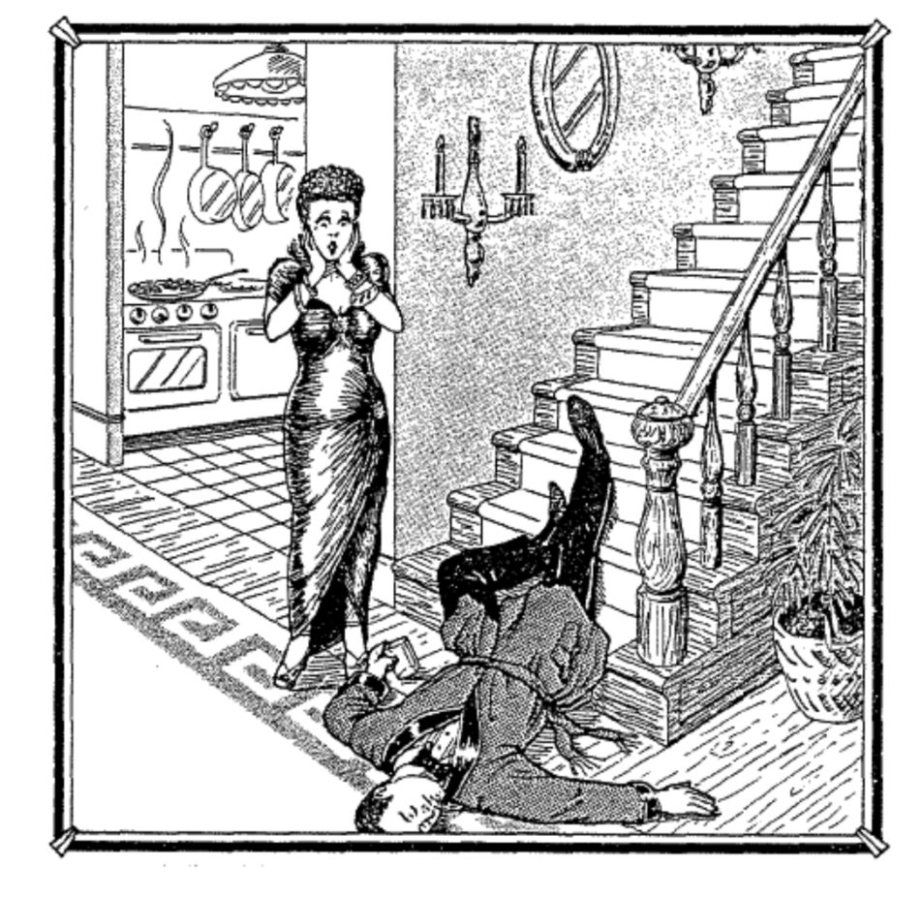
The autopsy conducted later concluded that Arthur had died from a wound on the head and confirmed that he’d been drunk.

Your Name:
Group Members’ Names:

The Question:
What is important to Mrs. Dabney?
Our Claim:
1.
2.
3.
Our Evidence: (at least 3 for each one)  1.  2.  3. | Reasoning of the Evidence:  1.  2.  3.

